**HATHARASINHAGE GAYATHRI KAUSHALYA**

1. Objective: **Seeking and academic position as a lecturer** in the field. Perform lectures, including teaching courses and supervising student in their academic assignment and research work, Good interpersonal and communication skills, Proficiency in computer-aided teaching.
2. Latest photo :

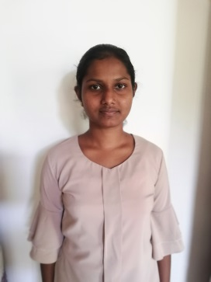

1. Personal details
   1. Address : NO:60, kandha Akkarayaya, Kella, Kolonna.
   2. Email ID : [hgkaushalya2000@gmail.com](mailto:hgkaushalya2000@gmail.com)
2. Phone number : 0765774369
3. Educational qualification
   1. Still Following a Bachelor of Science (Hons) in Biotechnology degree in the SLIIT University- Malabe.
   2. Advanced Level : 2018
      1. Biology – S iv. General English - S
      2. Chemistry – S v. General knowledge - 70
      3. Physics – S vi. General Information Technology – C
   3. Ordinary Level : 2015
      1. Sinhala – A vi. History - A
      2. English – B vii. Geography - A
      3. Mathematics – B viii. Sinhala literature - A
      4. Science – A ix. Home Science - A
      5. Buddhism – A
4. Extracurricular Activities
   1. Followed a Microsoft Office computer course in NAITA Embilipitiya.
   2. Experienced as a Prefect in Embilipitiya president’s college.
   3. A Member of the sport club in Kolonna.